Phase 1E - Northern Arc, Burgess Hill
4ha Employment Land
Register of Interest Form

Background
Homes England are looking to market Phase 1E of the Northern Arc, Burgess Hill development in early 2022.The opportunity is 5ha of employment land (currently greenfield land).
Location
The site is located at the western end of the Northern Arc masterplan, a 3,500-home scheme (including minimum of 30% affordable) in addition to two primary schools, a secondary school, three mixed use neighbourhood centres, including two standalone community facilities.
Situated in an excellent location south of the A2300 and close to nearby motorway links, the site is also north of land designated for the Centre for Outdoor Sports, east of directly adjacent ‘Hub’ employment site, encouraging business linkages and integration between new and existing residents.
Phase 1D lies to the east of the site and will be developed for housing (c.300 homes) and a neighbourhood centre, to be marketed in the New Year.

Planning Parameters

Phase 1E is suitable for a range of employment uses such as offices, research and development and industry.
In October 2019 outline planning permission was granted for the scheme. This permission set out certain land use parameters for the employment land (as contained in the Design Guidance, paras 3.16 -3.17). These are:
- Maximum floorspace 24,000 sq m (B1 and B2)
- Not more than 2,500 sq m to be B1(a) offices
- Other B1(b), B1(c) or B2 floorspace where the office use is not the predominant use.
There are also requirements on the developer to deliver pedestrian and cycle access, vehicular access, and car parking.
The link road serving the employment land is being constructed by Homes England through contractor Jacksons and should be completed towards the end of 2022. This will allow the provision of services and access to the surrounding development plots.
Plans
Phase 1E is located at the western end of the Northern Arc masterplan, as outlined below.
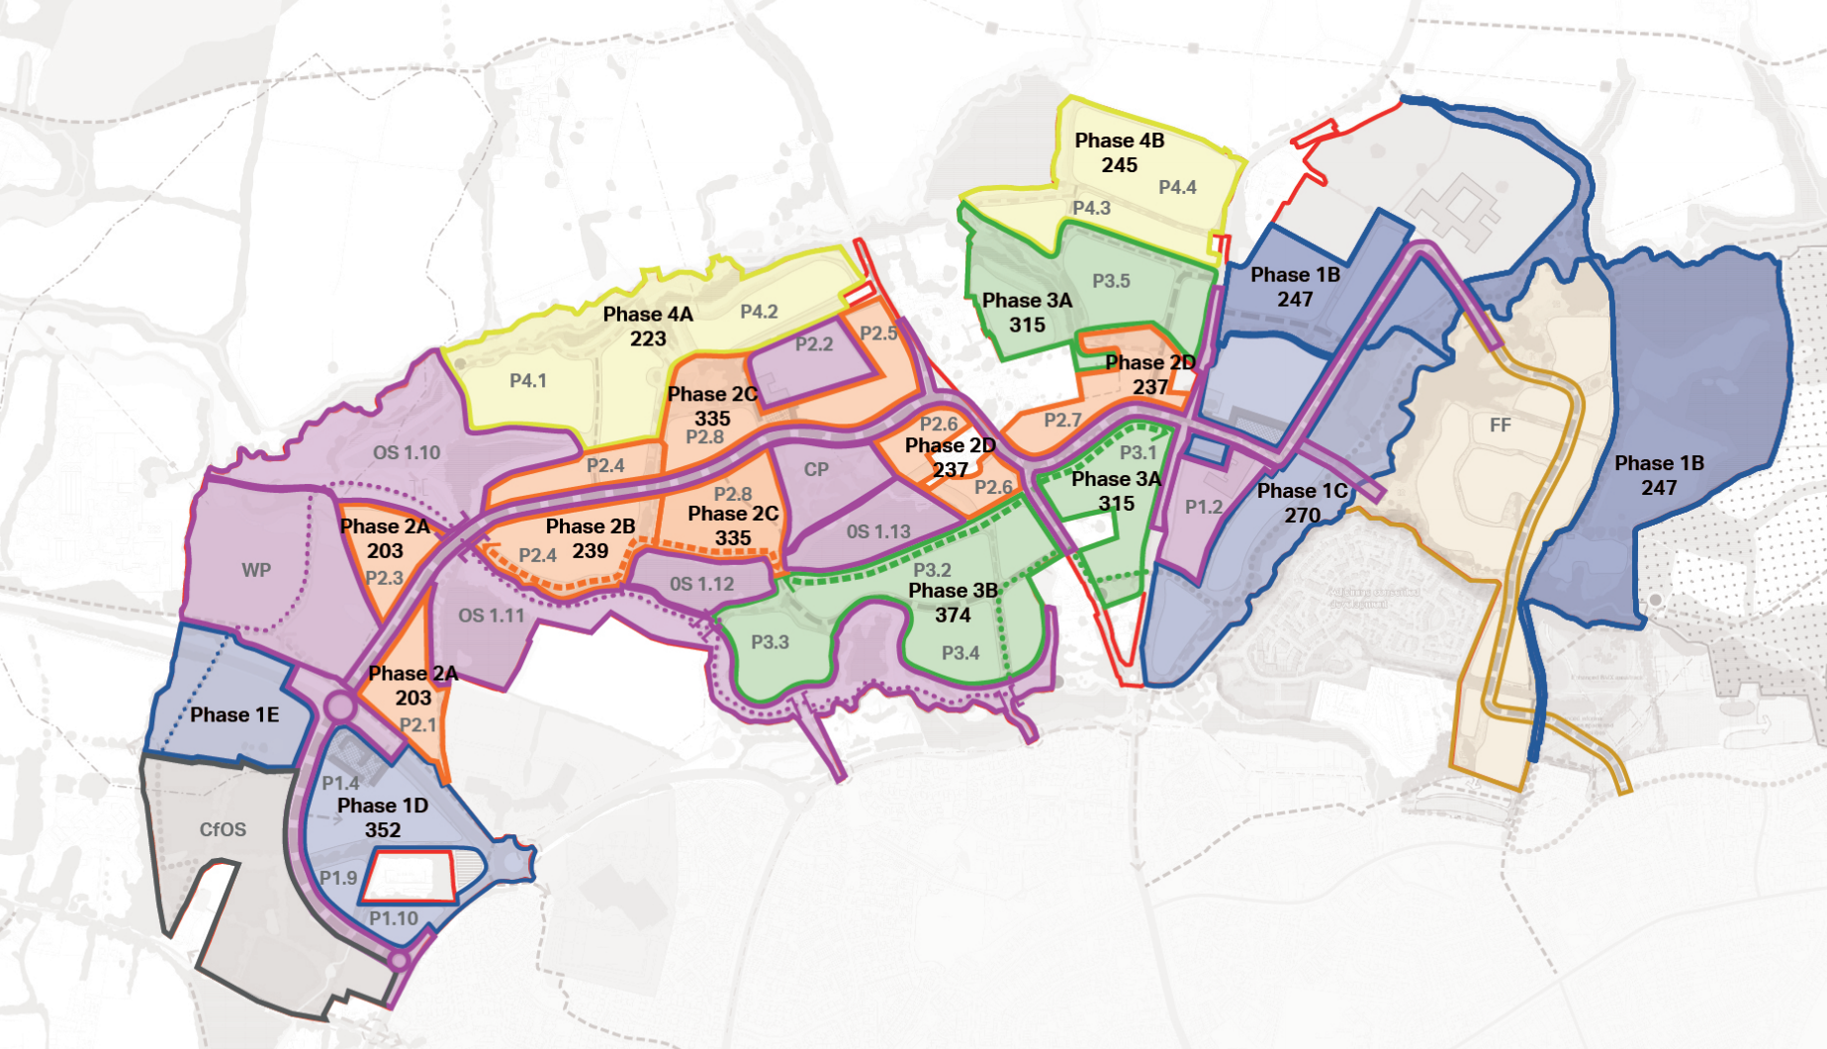

Site Location Plan (Phase 1E in orange)
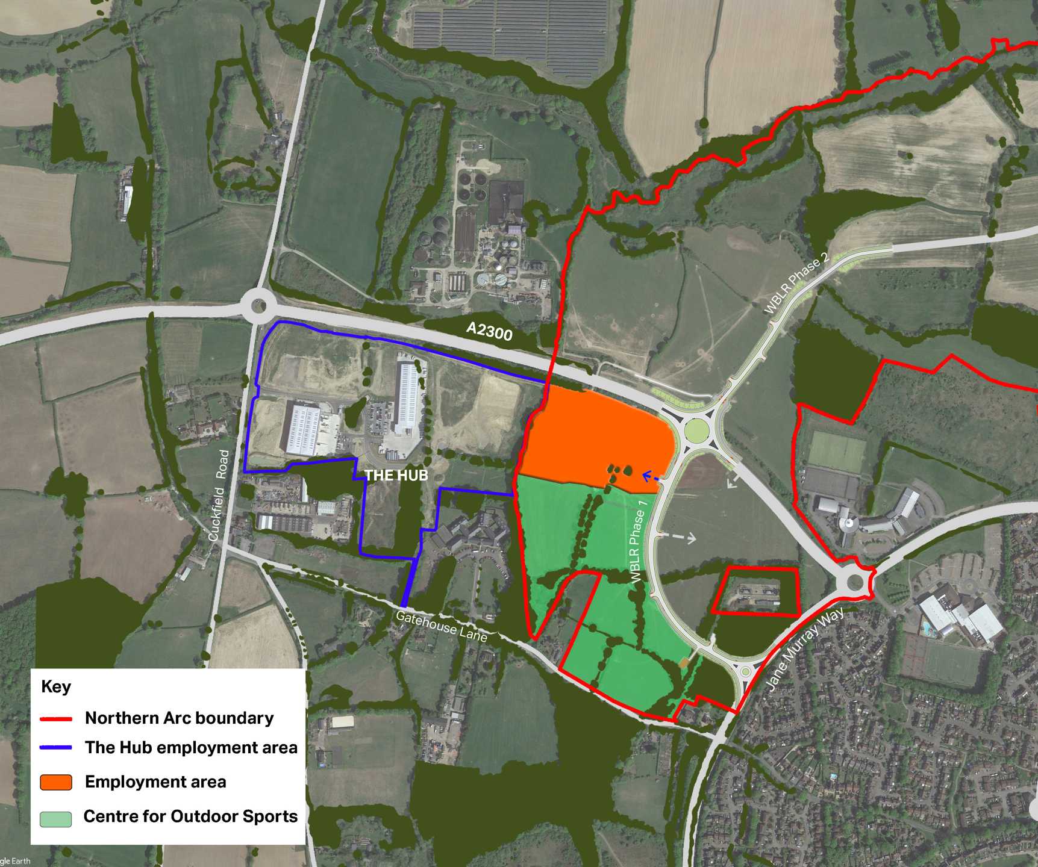

Outline permission design parameters
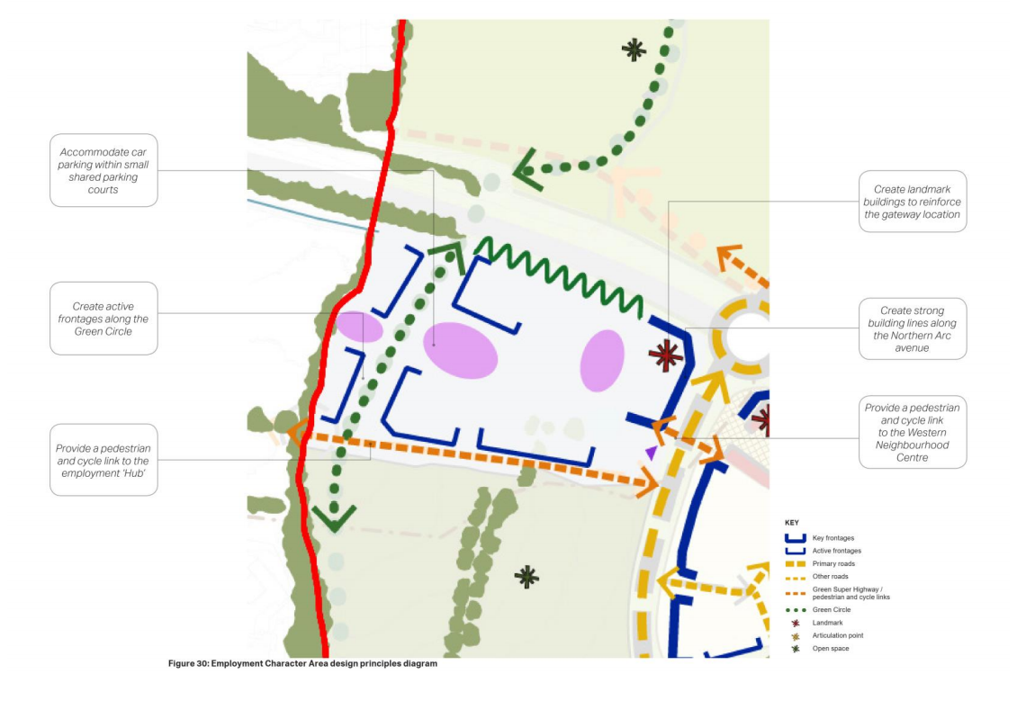

Register your interest
Please complete the below form to register your interest in the site and return to louisa.henry@homesengland.gov.uk or your local Business Association Contact.
Name
Organisation
Contact Details
Nature of interest | i.e., occupier (specify use class) / developer/ agent
Specific Requirements | i.e., size of space required, timing, any additional requirements (parking/ turning provision for vehicles/ access)
Preferred Structure | i.e. leasehold/ freehold / any specific terms
Further Comments | Any further comments regarding requirements / interest/ proposed development

Key Contacts

For further information please contact
Louisa.henry@homesengland.gov.uk
Graham.hyslop@homesengland.gov.uk

gov.uk/homes-england

